Resources for Students During School Closures

IMPORTANT: If you or someone you know is in danger, call 000 immediately.

Want to talk to someone?

Name | About | Phone | Webchat
Kids Help Line | Kids Helpline is Australia’s only free, private and confidential 24/7 phone and online counselling service for young people aged 5 to 25. | 1800 55 1800 | https://kidshelpline.com.au/get-help/webchat-counselling
Lifeline  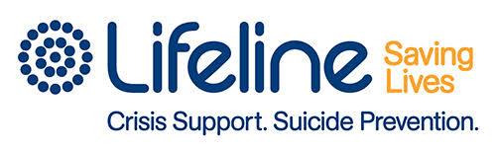 | Lifeline is a national charity providing all Australians experiencing a personal crisis with access to 24 hour crisis support and suicide prevention services. | 13 11 14 | https://www.lifeline.org.au/
Suicide Call Back Service  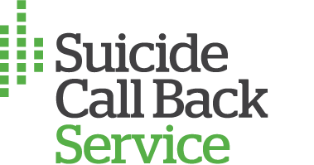 | A nationwide service that provides professional 24/7 telephone and online counselling to people who are affected by suicide. | 1300 659 467 | https://www.suicidecallbackservice.org.au/
Youth Beyond Blue | Beyond Blue provides information and support to help everyone in Australia achieve their best possible mental health, whatever their age and wherever they live. | 1300 22 4636 | https://www.youthbeyondblue.com/
ReachOut | Our mission is to deliver innovative e-mental health services that enable young people to take control of their mental health and wellbeing. | N/A | https://au.reachout.com/
SANE Australia  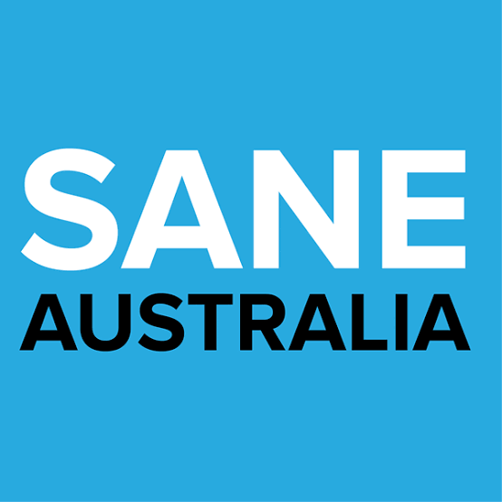 | SANE Australia is a national mental health charity making a real difference in the lives of people affected by complex mental health issues through support, research and advocacy. | 1800 187 263 | https://www.sane.org/about-sane
Headspace  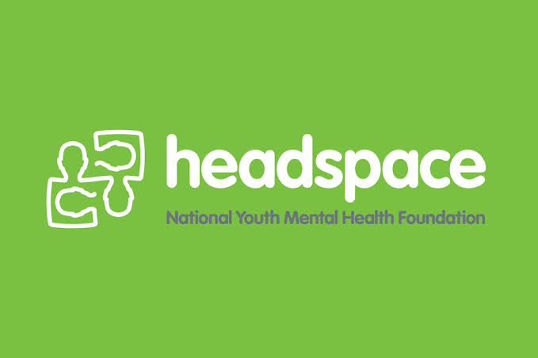 | eheadspace provides free online and telephone support and counselling to young people 12 - 25 and their families and friends. | National Office: (03) 9027 0100 | https://headspace.org.au/eheadspace/

Want to look online for support?

Name | About | Website
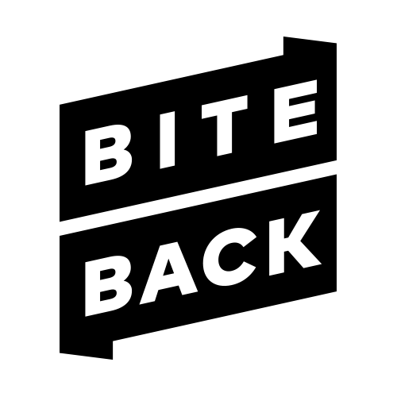  Bite Back | Promoting resilience and wellbeing in 12-18 year olds through activities. | https://www.biteback.org.au/
The BRAVE Program | BRAVE-ONLINE is an evidence-based cognitive behavioral therapy (CBT) available online to help children (8-12) and teenager (13-17) cope with anxiety. | https://www.brave-online.com/
ConnectEDSpace | A website provided by Relationships Australia Victoria with tip sheets, news and useful links to help young people manage problems and issues such as bullying, relationships, stress and mental health, and conflict with parents. | https://www.connectedspace.com.au/
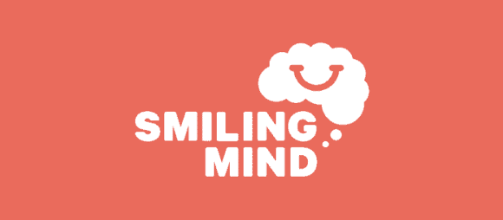  Smiling Mind | Online and app based program to improve wellbeing of young people through mindfulness meditation. | https://www.smilingmind.com.au/

