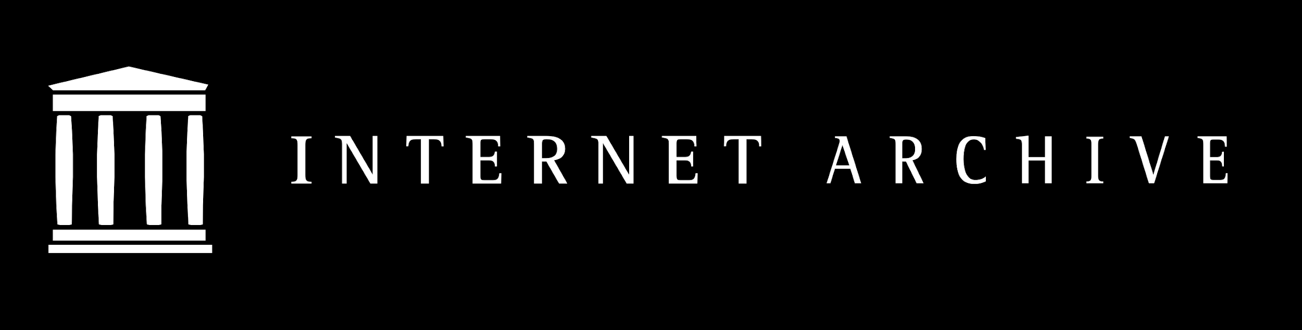

Frequently Asked Questions
about the National Emergency Library
March 24, 2020

Website: https://archive.org/details/nationalemergencylibrary
Announcement: http://blog.archive.org/2020/03/24/announcing-a-national-emergency-library-to-provide-digitized-books-to-students-and-the-public
Questions? Please write to us at info@archive.org

About
- Who can use the library? This is a global pandemic, is your library open to everyone?
Yes, the Internet Archive loans digitized books to the world. Our digital library is free to read for anyone with an internet connection, anywhere in the world. We are a global library.
- Why is it called a “National Emergency” Library when it’s open to the world?
We wanted to be very clear about the duration of this emergency library. It is meant to meet a specific, extraordinary need - universities, school, and libraries around the world are closed and people cannot access the physical materials within. While we serve the world, we operate in the United States, and so we are taking the extraordinary measure to suspend waitlists on our lending collection through the duration of the US national emergency to meet the educational and inspirational needs of a global community of readers and learners.
- How long will the National Emergency Library be in operation?
The library will have suspended waitlists through June 30, 2020, or the end of the US national emergency, whichever is later. After that, waitlists will be dramatically reduced to their normal capacity, which is based on the number of physical copies in Open Libraries.
- Who supports this effort?
Support for suspending waitlists has been broad across the library and educational communities. Lend your support today.
- Why is the Internet Archive doing this?
According to UNESCO, the COVID-19 crisis has shuttered the classrooms for one-in-five students worldwide, plus an additional one-in-four from higher education classes. And that number is growing, quickly approaching 1 billion students physically cut off from classrooms, teachers and libraries.
Internet Archive’s mission is to provide “Universal Access to All Knowledge.” We believe this is an extraordinary moment in time that requires assistance at a scale that we are able to provide. Suspending waitlists will put books in the hands of people who need them, supporting emergency remote teaching, research activities, independent scholarship, and intellectual stimulation while universities, schools, training centers, and libraries are closed.

Access
- How do I sign up for access?
Signing up for an Internet Archive account is free and open to the world. Please visit https://archive.org/account/signup If you have any problems, please write to info@archive.org
- How do I check out a book?
You can browse our collection or search for books or authors at https://archive.org/details/nationalemergencylibrary Use the “Search this Collection” box along the left to begin. During this time of emergency, users can check out up to 10 books at a time.

- What if I’m still reading my book when my 14-day loan is up?
While waitlists are suspended you will be able to check the book out again. Once waitlists are back in place at the end of the US national emergency, users will once again join waitlists to view available copies.
- I’m an educator. Will this work for a classroom of students?
Yes. Part of our reasoning to suspend waitlists was to meet this classroom need, expressed to us by many educators and librarians as their schools closed.

Collection
- What’s in your collection?
Great books! We worked with Phillips Academy, Andover to digitize their entire library, giving high school students everywhere access to a world-class school library. https://archive.org/details/phillipsacademy
Last year we received the entire contents of the Marygrove College library when the school closed in December, featuring a collection rich in materials relating to social justice. https://archive.org/details/marygrovecollege

We also received a donation of 250,000 books from Trent University, comprising research monographs from the latter half of the twentieth century. https://archive.org/details/trent_university

We have taken several different strategies to build our collection. We’ve been working off a wish list of titles gathered by comparing lists of the most cited books in Wikipedia, the most commonly held books by academic and public libraries in the US and Canada, and books assigned in syllabi and course listings.

All in all, we have worked to build a collection that represents the reading and research interests of patrons of both academic and public libraries. We have also worked to build a collection that is inclusive and reflects the diverse voices in our community.

- Do you have textbooks?
No, not many. We have older textbooks that have been donated from libraries, but we don’t have recent materials.
- I get ebooks from my public library. How is this different from OverDrive or Hoopla?
Our focus is providing online access to older books that don’t have an ebook. OverDrive and Hoopla are great services and we fully support your public library and their work in making those books available to you. Those services generally have the latest bestsellers and popular titles, along with a limited backlist. Think of our collection as complementary - we have focused on acquiring and digitizing books from the 1920s-1990s that don’t have an ebook available except for our scanned copy.
- Where do you get your books?
The Internet Archive has a special partnership with Better World Books, now owned by a non-profit, which receives its books from libraries and individuals. We also purchase books and receive books through major donations.
- What about older books?
Yes, the Internet Archive has over 2.5 million books that are in the public domain. Those books do not require any waitlist at any time because they are out of copyright and can be freely read and redistributed.

Participation
- How can I contribute?
Readers, please sign up for an account and browse our collection. Borrow up to 10 books at a time and give us feedback on your experience.

Publishers and authors, if you have digital books you would like to donate, please contact Chris Freeland, Director of Open Libraries.
- If I am an author and I do not want my book to be temporarily available during this crisis, how can I remove my book from the National Emergency Library?
Authors who do not want their books in the National Emergency Library should send an email to info@archive.org with “National Emergency Library Removal Request” as the subject line. Please include each URL of the book or books you would like to have removed. Please allow up to 72 hours for processing as we are a small team.

- Can I donate books?
Individuals: Please donate your books to Better World Books. They have dropboxes in the US and UK.
Libraries: Please contact Better World Books.
- Are there other ways I can support this effort?
Yes, individuals can donate cash, cryptocurrency, securities and estate gifts.
Donate Online
Make an individual gift large or small online at archive.org/donate or at archive.org/donate/cryptocurrency. If you want to make an estate gift
contact joy@archive.org.
Amazon Smile
When you sign up for Amazon Smile and choose the Internet Archive as your donation beneficiary, Amazon will donate .5% of every purchase you make to the Archive. To sign up and support us, visit: https://smile.amazon.com/ch/94-3242767
Round up at BetterWorldBooks.com
When you purchase a book from Better World Books, you have the option of rounding up your purchase to support Internet Archive.

Administration
- What will happen after the end of the US national emergency?
The waitlist suspension will run through June 30, 2020, or the end of the US national emergency, whichever is later. After that, the waitlists will be dramatically reduced to their normal capacity, which is based on the number of physical copies in Open Libraries.
- Is this controlled digital lending?
No. It is close to controlled digital lending but is significantly different while waitlists are suspended. This library is being mobilized in response to a global pandemic and US national emergency. It shares aspects of controlled digital lending by controlling the physical book that was scanned and the redistribution of files through digital rights management software, but differs by having no waitlists for users borrowing books. Once the US national emergency is over and waitlists are back to their normal capacity, the service will return to full controlled digital lending.
- Do you have APIs or downloads of your data?
Yes, the Internet Archive has extensive APIs that you can use to interact with our collections. You can download a simple list of the ISBNs represented in our collection at https://archive.org/download/ia-current-isbns/current-isbns.tsv. This file is updated daily.

