Prairiewood High School

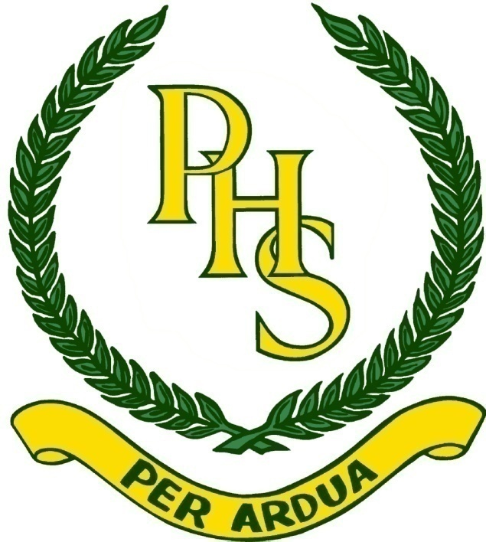

‘Challenging Students for the Future’

Acclaim/Investiture Assembly
&
Annual Presentation
8th December, 2020
Order of Assembly
Chairpersons: Phuong Nguyen, Jayden Truong B Bonny Chung, Ryan Taghvaei
1. Introduction……………..…...…………...Phuong Nguyen, Jayden Truong
2. Acknowledgement of Country……………..…...………….….Mrs L Marlow
3. National Anthem…………………………………..…Brooke Lesumainaivalu
4. Prefect 2020 Certificates……………………………..…….……Mr J Nguyen
5. SRC 2020 Certificates………………...…….....….Ms G Valatiadis, Ms M Liu
6. SPC 2020 Certificates………………………..…........Mr K Fisher, Ms N Dixon
7. Outstanding Student Leader…................………….Mentor, Ms B Giudice
8. Investiture of Prefects 2021…………………….…Ms K Chen, Mr J Nguyen
9. Investiture of SRC 2021……..……..…………......Ms G Valatiadis, Ms M Liu
10. Investiture of SPC 2021…………...………………….Mr K Fisher, Ms N Dixon
11. Leadership Pledge……………………………………………..…Ms B Giudice
12. ‘Like I’m Gonna Lose You’……………………………………...Year 11 Band
13. School Captains Address…………..…..Phuong Nguyen, Jayden Truong
14. Principal’s Remarks…………………………………….…………Ms B Giudice
15. Presentation of Year 7 Awards………………...….Ms M Beatriz, Ms L Parisi
16. Presentation of Year 8 Awards…………………..Ms A Honess, Ms N Musa
17. Presentation of Year 9 Awards………………..Ms S Blazevska, Ms N Dixon
18. Students’ Annual Report………………Phuong Nguyen, Jayden Truong
19. Presentation of Year 10 Awards………………………Mr J Lai, Mr A Yousif
20. Presentation of Year 11 Awards……………………Ms K Bond, Ms A Hiew
21. Special Awards
VET Outstanding Work Ethic…………………..……..Ms K Chen, Ms A Pool
VET Student of the Year…………………………....…Ms K Chen, Ms A Pool
Gerry Bianchini Public Education Award.............. Ms K Chen, Ms A Pool
John Pickering Performing Arts Award………. Ms K Chen, Ms A De Carli
Aleks Lukic Memorial Award…..………….....… Ms K Chen, Ms A De Carli
Special Education Hospitality Award.............. Ms K Chen, Ms A De Carli
ADF Awards for Leadership……….…….............. Ms K Chen, Mr A Judge
Parliamentary Award……………..………………. Ms K Chen, Mr A Judge
Greta Dowd Memorial Awards……….....…..…...Ms K Chen, Mr A Judge
HSC Award 2019………………………...……………………..... Ms B Giudice
Dux of Years 7, 8, 9, 10, 11…………….....Deputy Principals, Ms B Giudice
19. Conclusion of Assembly……………...…Phuong Nguyen, Jayden Truong

Distinguished Guests

Ms B Giudice | Principal
Mr A Judge | Deputy Principal
Mr M Kumar | Deputy Principal
Ms A De Carli | Deputy Principal
Ms A Pool | Deputy Principal (Rel)
Ms K Chen | Head Teacher Secondary Studies
Ms L Marlow Ms K Hernandez | Head Teachers, Wellbeing
Ms M Beatriz Ms L Parisi | Year 7 Student Advisers
Ms A Honess  Ms N Musa | Year 8 Student Advisers
Ms S Blazevska  Ms N Dixon | Year 9 Student Advisers
Mr J Lai Mr A Yousif | Year 10 Student Advisers
Ms K Bond  Ms A Hiew | Year 11 Student Advisers
Ms K Chen  Mr J Nguyen | Prefect Executive  Prefect Mentor
Ms G Valatiadis  Ms M Liu | SRC Executive  SRC Mentor
Mr K Fisher  Ms N Dixon | SPC Executive  SPC Mentor

Prefects 2020

Mentor: | Mr J Nguyen
Executive: | Ms K Chen

School Captains |  | School Vice Captains
Georgia Elphinston  Ella-Rose Smee |  | Henry Duong  Fiona Lim
Prefects
Kristie Caplikas | Anne Chau | Vivien Chor | Kaitlyn Doan
Cindy Doan-Vo | Desmond Hwang | Leon Kee | Anna Le
Jewel Mathew | Jason Meas | Amber Nguyen | Selina Nguyen-Tran
Henry Pham | Rinki Tsui | Kathleen Vuong | Yaqo Yaqo
Outstanding Student Leader 2020 – Georgia Elphinston

- Represented PHS at Peace Day
- Year 7 Camp
- White Ribbon Assembly
- Senior Subject Seminars
- Online Senior Subject Selection Night
- Positive Social Media Influence
- Homework Centre
- Teacher Appreciation Day
- Interschool Sports Competition

Student Representative Council 2020

Mentor: | Ms M Liu
Executive: | Ms G Valatiadis

Yr 11 | Zahraa Aljanabi | Yr 9 | Jayden Britten
Yr 11 | Zac Hide | Yr 9 | Felix Hang
Yr 11 | Phuong Nguyen | Yr 9 | Jazlyn Singh
Yr 11 | Aditya Singh | Yr 9 | Jason Tang
Yr 11 | Mark Tran | Yr 8 | Hannah Kilicoglu
Yr 11 | Jayden Truong | Yr 8 | Lynn Le
Sp Ed | Christopher Makko | Yr 8 | Amy Nguyen
Yr 10 | Lauro Ho | Yr 8 | Johnny Stamiris
Yr 10 | Palanitina Iosefa | Yr 7 | Vanessa Cai
Yr 10 | Jonathan Ou | Yr 7 | Annabel Huor
Yr 10 | Anthony Phan | Yr 7 | Erika Nguyen
 |  | Yr 7 | Damian Pivas
Outstanding Student Leader 2020 – Felix Hang

- Facilitated ‘Clean Up Australia Day 2020’ at PHS with Year 7
- Facilitated school tours with Fairfield High School Intensive English Centre students
- Fundraise for the Beirut appeal on behalf of the Australian Red Cross
- Participation in the Year 7 Orientation night as school guides
- Assisted with promoting the new school uniform to the community via social media platforms
- Contribution to the social media platforms
- Continuing the program of collecting recycling from around the school
- Contributed to the layout of school bins across school grounds
- Assisted in SRC Elections

Sports Council 2020

Mentor: | Ms N Dixon
Executive: | Ms K Fisher

House | House Captains | House Vice Captains | House Patrons
COBRAS | Ashley Coleman Izaiah Crichton | Bonny Chung  Hugo Da Cunha | Ms S Blazevska  Miss K Chen
HAWKS | Brooke Lesumainaivalu Joshua Huynh | Bridget Khoupraseuth  Kobe Luu | Mrs A Curmi  Mr J Nguyen
MUSTANGS | Stella Nguyen Joshua Moon | Leela Ma-Chong Nicholas Pinoschi | Mrs N Dixon
SCORPIONS | Kayla Truong Patrick Ye | Nikoletta Tsagalias Kingston Sun | Mr K Fisher  Mrs A Isler
Outstanding Student Leader 2020 – Joshua Moon

- Swimming carnival including novelty events
- Athletics and Cross Country carnivals – record attendances at all carnivals
- Year 7 and 8 Gala Days
- Assist at Lansdowne Zone Swimming Carnival
- Interschool Sports Competition
- Assist with 2020 Photo day

Prefects 2021

Mentor: | Mr J Nguyen
Executive: | Ms K Chen

Captain: | Phuong Nguyen
 | Jayden Jing Hao Truong
Vice Captain: | Bonny Chung
 | Ryan Taghvaei

Prefects: | Zahraa Aljanabi
 | Winston Chau
 | Narina Folino
 | Belinda Hanna
 | Zac Hide
 | Bryant Lam
 | Angela Le
 | Keali Longdon
 | Nhi Lu
 | Joshua Moon
 | Nicholas Pinoschi
 | Aditya Singh
 | Mark Tran
 | Steffi Tran
 | Nikoletta Tsagalias
 | Ryan Vilaythong

Student Representative Council 2021

Mentor: | Ms M Liu
Executive: | Ms G Valatiadis

Yr 10 | Talitha Chin
Yr 10 | Izaiah Crichton
Yr 10 | Alisa Lam
Yr 10 | Taylah Ly
Yr 10 | Dylan Trung Nguyen
Yr 10 | Anthony Phan
Yr 10 | Jonathan Ou
Spec Ed | Bree-Anne Fricker
Yr 9 | Jayden Britten
Yr 9 | Angeli Cai
Yr 9 | Jason Tang
Yr 9 | Henry Tat
Yr 8 | Alok Honess
Yr 8 | Jenny Nguyen
Yr 8 | Christine Phung
Yr 8 | Johnny Stamiris
Yr 7 | Vanessa Cai
Yr 7 | Erika Nguyen
Yr 7 | Alicia Pan
Yr 7 | Damian Pivas

Sports Council 2021

Mentor: | Ms N Dixon
Executive: | Ms A Pool

COBRAS

House Captains | Raymond Duong
 | Olivia Elphinston
House Vice Captains | Belinda Bennett
 | Thomas Doan
 | Rabab Fanoosh
House Patrons | Ms S Blazevska
 | Miss K Chen
HAWKS

House Captains | Felix Hang
 | Royce Kouch
House Vice Captains | Michelle Hoang
 | Christopher Huynh
House Patrons | Mrs A Curmi
 | Mr J Nguyen
MUSTANGS

House Captains | Thomas Moon
 | Stella Nguyen
House Vice Captain | Brendan Nguyen
House Patrons | Ms N Dixon
SCORPIONS

House Captains | Dylan Truong
 | Hannah Truong
House Vice Captains | Eddie Thach
 | Chloe Truong
House Patrons | Mr K Fisher
 | Mrs A Isler

Year 7 Academic Award

Year Adviser: | Ms M Beatriz
Year Adviser: | Ms L Parisi

Dux of Year | Ali Kilicoglu | Dux of Year Selective | David Ly
Second in Year | Andres Alsedi | Second in Year Selective | Kaylee Khoupongsy
Third in Year | Alicia Ly | Third in Year Selective | Annabel Huor

English | Ahmad Al-Rubai’e
English Selective | David Ly
Geography | Ali Kilicoglu
Geography Selective | Annabel Huor
Mathematics | Anthony Tran
Mathematics Selective | Nelson Tran
Music | Jack Chammo
Personal Development, Health, Physical Education | Ali Kilicoglu
Personal Development, Health, Physical Education Selective | Kaylee Khoupongsy
Science | Andres Alsedi
Science Selective | David Ly
Special Education Award | Rafael Galea
Technology | Esmeralda Ureta
Technology Selective | David Ly
Visual Arts | Erika Nguyen
Visual Arts Selective | Salina Nguyen

Year 8 Academic Award

Year Adviser: | Ms A Honess
Year Adviser: | Ms N Musa

Dux of Year | Johnny Stamiris | Dux of Year Selective | Britney Nguyen
Second in Year | Jahnavi Maharaj | Second in Year Selective | Sienna Korendis
Third in Year | Yenuli Peiris | Third in Year Selective | Alexander Chea

English | Johnny Stamiris
English Selective | Britney Nguyen
History | Gianelle Guendjian
History Selective | Sienna Korendis
French | Johnny Stamiris
French Selective | Sienna Korendis
Japanese | Ngoc Thai Xuan Huynh
Japanese Selective | Jenny Nguyen
Mathematics | Jahnavi Maharaj
Mathematics Selective | Alexander Chea
Music | Kasey Huynh
Personal Development, Health, Physical Education | Johnny Stamiris
Personal Development, Health, Physical Education Selective Selective | Allie Hang
Science | Jahnavi Maharaj
Science Selective | Britney Nguyen
Special Education Award | Matthew Mendez
Technology | Scarlett Pham
Technology Selective | Jonathan Tran
Visual Arts | Johnny Stamiris

Year 9 Academic Award

Year Adviser: | Ms S Blazevska
Year Adviser: | Ms N Dixon

Dux of Year | Alex Le | Dux of Year Selective | Steven Nguyen
Second in Year | Katrina Quach | Second in Year Selective | Andy Chung
Third in Year | Felix Hang | Third in Year Selective | Kevin Nguyen

English | Lily Tieu
English Selective | Steven Nguyen
Geography | Alex Le
Geography Selective | Steven Nguyen
History | Alex Le
History Selective | Angeli Cai
Mathematics 5.1 | Alex Le
Mathematics 5.2 | Mark Lam
Mathematics 5.3 | Andy Chung
Mathematics Accelerated | Andy Chung
Personal Development, Health, Physical Education | Rachel O’Halloran
Personal Development, Health, Physical Education Selective | Kevin Nguyen
Science | Thomas Moon
Science Selective | Steven Nguyen
Special Education Award | Eric Doan

Year 10 Academic Award

Year Adviser: | Mr J Lai
Assistant Year Adviser: | Mr A Yousif

Dux of Year | Timothy Kem | Dux of Year Selective | Jessica Nguyen
Second in Year | Sydney Bui | Second in Year Selective | Taylah Ly
Third in Year | Caitlin Huynh | Third in Year Selective | Heather Sengmany

English | Timothy Kem
English Selective | Taylah Ly
Geography | Angela Tran
Geography Selective | Jessica Nguyen
History | Angelina Miller
History Selective | Jessica Nguyen
Mathematics Accelerated | Michele Tran
Mathematics Extension 1 Accelerated | Richard Pech
Mathematics 5.1 | Yasemin Akdogan
Mathematics 5.2 | Eric Vuong
Mathematics 5.3 | Timmy Ha
Personal Development, Health, Physical Education | Belinda Bennett
Personal Development, Health, Physical Education Selective | Kirached Siackhasone
Science | Timothy Kem
Science Selective | Ella Chen
Special Education Award | Bree-Anne Fricker

Stage 5 Academic Award

Agricultural Technology | Caitlin Chua
Astronomy | Taylah Ly
Child Studies | Shelley Tang
Commerce | Alan Nguyen
Design and Technology | Stefan Grujic
English Extension | Kevin Nguyen
Food Technology | Stefanie Grujic
History’s Mysteries | Jonathan Luo
Hospitality | Alisa Lam
Industrial Technology Engineering | Melvin Lanojan
Industrial Technology Timber | Celeste Di Natale
Information & Software Technology | Melvin Lanojan
Japanese | Jessica Nguyen
Music | Angeli Cai
Photographic & Digital Media | Heather Sengmany
Physical Activity and Sport Studies | Eric Pham
Visual Arts | Jessica Nguyen
Visual Design | Alisa Lam

Year 11 Academic Award

Year Adviser: | Ms K Bond
Assistant Year Adviser: | Ms A Hiew

Dux of Year | Angela Le
Second in Year | Nabolyn Chhay
Third in Year | Brendan Ta

Biology | Nabolyn Chhay
Business Studies | Angela Le
Chemistry | Brendan Ta
Community and Family Studies | Milada Salim
Design and Technology | Colin Phu
Economics | Jayden Truong
Engineering Studies | Daniel Marenco
English Extension | Michelle Ung
English Advanced | Michelle Ung
English EAL/D | Qui Ngoc Tran
English Standard | Narina Folino
English Studies | Shireen Yonan
Geography | Trisha Nguyen
History Ancient | Steffi Tran
History Modern | Kate Rodionoff
Italian Beginners | Daniel Marenco
Japanese Continuers | Chelsea Sonia Yap
Legal Studies | Jasmine Tran
Mathematics Advanced Accelerated | Brendan Ta
Mathematics Advanced | Quang Huynh
Mathematics Extension 1Accelerated | Angela Le
Mathematics Extension 1 | Mark Quach
Mathematics Standard 1 | Nataly Esttaifan
Mathematics Standard 2 | Victoria Nguyen
Music | Simran Sambhy
Personal Development, Health, Physical Education | Harrison Duong
Photography, Video & Digital Imaging | Dylan Simon
Physics | Ryan Taghvaei
Society and Culture | Steffi Tran
Software Design and Development | Derik Sourignavong
Special Education Award | Christopher Makko
Sport, Lifestyle, Recreation Studies | Chloe McGann
Visual Arts | Nhi Lu
Work Studies | Ethan Le

Year 12 Academic Achievement

Year Adviser: | Mr M Mears
Assistant Year Adviser: | Mr M Mount

Dux | Kristy Lam
Dux | Angella Pham
Second in Year | Annalise Pean
Third in Year | Ryan Ly

Ancient History | Aeisha Benito
Biology | Shann Tok
Business Studies | Amber Nguyen
Chemistry | Angella Pham
Community and Family Studies | Sharni Frank
Economics | Annalise Pean
English Advanced | Kristy Lam
English Extension 1 | Kristy Lam
English Extension 2 | Selina Nguyen Tran
English EAL/D | Bao Nghi Hoang
English Standard | Georgia Elphinston
English Studies | Leilania Loau
Exploring Early Childhood | Gjorja Lajkoski
Food Technology | Huu Bao Nghi Hoang
Geography | Hayden Dos Anjos
History Extension | Kristy Lam
Industrial Technology Timber | Rabieh Trabulsi
Information Processes & Technology | Huu Bao Nghi Hoang
Italian Beginners | Ella-Rose Smee
Legal Studies | Annalise Pean
Mathematics Advanced | Elissa Luong
Mathematics Extension 1 | Elissa Luong
Mathematics Extension 2 | Ryan Ly
Mathematics Standard 1 | Brian You
Mathematics Standard 2 | Hayden Dos Anjos
Modern History | Kristy Lam
Music 1 | Eric Do
Personal Development, Health, Physical Education | Ella-Rose Smee
Physics | Ryan Ly
Science Extension | Kristie Caplikas
Society and Culture | Annalise Pean
Sport, Lifestyle and Recreational Studies | Lillian Marshall
Visual Arts | Kristie Caplikas
Work Studies | Kristell Ave

P & C Academic Achievement Award

Year 11 | Ceren Aciksen, Nohra Adam, Zahraa Aljanabi, Helen Chau, Belinda Hanna, Richie King, Alex Lasek, Ngoc Le, Keali Longdon, Elizabeth Ngo, Shikira Ngo,  Alex Nguyen, Jessica Nguyen, Oriana Nguyen, Phuong Nguyen, Dany Saadeh, Valeria Salazar-Oscategui, Hubert Tang, Mark Tran, Nikoletta Tsagalias, Pauline Tufuga, Ryan Vilaythong, Jessica Vuong, Isaac Won, Jiayu Xu
Year 10 | Patrick Bui, Mathew Chandra, Talitha Chin, Mohammed Elzahr ,Rabab Fanoosh , Trang Hoang, Yen Hoang, Caitlin Huynh, Denton Kev, Jayden Lam, Jodie Lang, Dylan Nguyen, Lily Nguyen, Jonathan Ou, Natalie Phan, Samnang Sem, Tara Stig, Eddie Thach, Theodore Tran, Nardin Yousif, James Yu, Iris Zhang, Jessica Zhang, Leanne Zhu
Year 9 | Ryadh Albu Ali, Alicia Atmawijaya, Kristine Bangug, Jack Bensemann,,Joshua Britten, Cody Din, Tjinlee Eung, Jason Ho, Ryan Hong, Tania Jozic, Callum Kelly, Kevin Kou, Robert Lin, Stavia Moshi, Ashley Nguyen, Brendan Nguyen, Jessica Pao, Jojo Pese, Tyson Pham, Olivia Pinna, Gabriel Surace, Jason Tang, Nalini Tran, Victor Truong, Courtney Wong
Year 8 | Sarah Chheav, Mary Chu, Melinda Fong, Luka Glavan, Filip Jovanov  Anna Khoun, Yasmin Kocak, Tina La, Alyssa Le, Lynn Le  Thuy Le, Adrian Ly, Izayah Manu, Sherine Mashat, Jessica Nguyen  Kelly Ong, Elhana Osmancevic, Sofia Pham, Zolanda Pham, Jessica Quach  Jessica Seng, Vietdantam Vu, Victoria Weng
Year 7 | Seren Adhikari, Soghita Asi, Julien Chamoun, Jayden Dinh, Kiana Edmon-Akhshirish, Harrison Hak, Dominic Lam, Yvonne Lam, Aidan Le, Christina Le, Kaylee Le, Ayush Maholtra, Rhiannon Mancini, Harrison Napper, Trung Tin Nguyen, Wendy Nguyen, Omol Baneen Sazegar, Madlin Somo, Kate Speranza, Eileen Tran

Debating and Public Speaking
Year 9/10 | Tara Lim, Jessica Nguyen, Heather Sengmany, Jessica Zhang
Year 7/8 | Allie Hang, Annabel Huor, Evy Huynh, Ayush Malhotra, Jenny Nguyen, Jessica Nguyen, Damien Pivas, Johnny Stamiris, Nathan Vilaythong, Sophia Vuong, Katelyn Xian
Legacy Junior Public Speaking Award
Semi-finalist

Johnny Stamiris
The Plain English Speaking Award
Semi-finalist

Jessica Nguyen
Premier’s Reading Challenge Certificate
Dishita Gupta, Ali Kilicoglu, Alicia Ly, Austin Ly, Arwan Rahma, Zachary Tucker, Luka Glavan, Hannah Kilicoglu, Sienna Korendis, Sofia Pham, Johnny Stamiris, Maya Stanley, Steven Nguyen

Gold Certificate
Tomin Jio

Platinum Certificate
Britney Nguyen

Medal
Caitlin Chua

Special Award Winners 2020

Aleks Lukic Memorial Award | Divina Duckworth
Australian Defence Force Award for Leadership | Jonathan Ou
Gerry Bianchini Public Education Award | Nhi Lu
Greta Dowd Memorial Scholarship Award | Jessica Nguyen  Brendan Ta
Higher School Certificate Award – 2019 | Ngan Nguyen
John Pickering Performing Arts Award | Ryan Vilaythong
Parliamentary Award | Nicholas Pinoschi
Special Education Hospitality Award | Divina Duckworth
VET Outstanding Work Ethic Award | Keali Longdon
VET Student of the Year Award | Brandon Tran

Special Awards

Aleks Lukic Memorial Award: presented to a Special Education student who has demonstrated active leadership and participation as well as providing encouragement and support to other students. This award was introduced for the first time in 2005 in memory of Aleks Lukic, a Special Education student from 1998-2005. A courageous young lady, admired by all for her positive and caring attitude.

Australian Defence Force Award: provided by the Australian Defence Forces for students who display outstanding leadership in a variety of areas in the school community.

Dux Award: presented to the top performing students in each year as determined in a point system by the number of First, Second and Third places received from each subject.

Gerry Bianchini Public Education Award: presented to a student who shows enthusiasm, talent and persistence for Science.

Greta Dowd Memorial Scholarship Awards: presented to a Year 11 Boy and Year 11 Girl who have shown outstanding commitment and dedication to their education in terms of their school work, school service and overall achievement. These scholarships were introduced by our Parents and Citizens’ Association in memory of the school’s first canteen supervisor, Mrs Greta Dowd, who was a dedicated worker and supporter of both our school and the P&C Association.

Higher School Certificate Award: presented to the student gaining the highest results for their best ten units at the Higher School Certificate Examinations in the previous year.

John Pickering Performing Arts Award: presented to a student who has shown excellence in performing arts. This award is in honour of our first Music Head Teacher.

Parents and Citizens’ Academic Achievement Award: presented to a student who has consistently demonstrated diligence in their academic studies.

Parliamentary Award: presented to a student who displays excellent leadership and passion for community service and social justice. The student is also diligent and proactive is assisting others within their community.

Special Education Hospitality Award: presented to a Special Education student who has achieved the most competencies throughout the year and excellent achievement in the school’s coffee shop simulated work placement.

VET Outstanding Work Ethic Award: presented to a Year 11 VET student who has displayed an outstanding work ethic.

VET Student of the Year: presented to a Year 11 VET student who has displayed outstanding skills in achieving work place competencies within the classroom and in the workplace.

Mission Statement

To strive for excellence in classroom teaching with students supported
by wide-ranging experiences and opportunities which enable them to develop as productive, effective and valued members of the community.

Prairiewood High School challenges students for the future by

- Providing a positive school environment which is ordered, safe, caring and valued by all members of the school community

- Promoting the development of positive attitudes and respect for all members of its multicultural school community

- Providing a quality curriculum which reflects the special talents, needs and interest of its students

- Providing teaching and non-teaching staff with opportunities for regular involvement in training and development activities

- Providing opportunities for students to develop skills in the use of computers and information technology

- Promoting the active participation of parents and community members as partners in its educational endeavours.

Staff Directory

Principal Ms Belinda Giudice
Deputy Principal |  | Ms Amanda De Carli |  |  |  |  |  | Deputy Principal |  |  |  |  |  | Mr Mukesh Kumar
 |  | (Years 8 & 11) |  |  |  |  |  |  |  |  |  |  |  | (Years 7 & 10)
Deputy Principal |  | Mr Alexander Judge |  |  |  | Deputy Principal Ms Alison Pool (Rel)
(Years 9 & 12)
Head Teacher Administration |  |  |  |  |  | Mr Claudio Acosta (Rel)
Head Teacher Secondary Studies |  |  |  |  |  | Ms Kristy Chen (Rel)
Head Teacher Student Engagement |  |  |  |  |  | Mrs Susan Davis
Head Teacher Wellbeing |  |  |  |  |  | Ms Karen Hernandez (Yrs 7, 9, 11, Hub) Ms Lynne Marlow (Yrs 8, 10, 12, CLOs)
Business Manager Mrs Luisa Maguire
Executive School Operations Support Officer Mrs Carol Richardson
Year Advisers
Year 7 | Year 8 |  |  | Year 9 |  |  |  |  | Year 10 |  |  | Year 11 |  |  |  | Year 12
Ms Molly Beatriz | Mrs Asishna Honess |  |  | Ms Simona Blazevzka |  |  |  |  | Mr Jordan Lai |  |  | Ms Kylie Bond |  |  |  | Mr Martin Mears
Ms Lisa Parisi | Ms Nora Musa |  |  | Ms Nicole Dixon |  |  |  |  | Mr Ala'A Yousif |  |  | Ms Hiew/Ms Inzitari |  |  |  | Mr Mitchell Mount
CAPA/LOTE |  |  | English |  |  |  |  |  | HSIE |  |  |  |  |  | Mathematics
Ms Georgia Valatiadis HT (Mon,Th) |  |  | Ms Mika Rodic HT (Rel) |  |  |  |  |  | Mr Chay Williams HT |  |  |  |  |  | Mr Ramesh Chand HT (Rel)
Ms Helen Li HT (Rel) (Tu,W, F)
Ms Stephanie Falk |  |  | Ms Jessica Abdul-Ahed |  |  |  |  |  | Mr Joel Bolton |  |  |  |  |  | Dr Butrus Altoon
Ms Amanda Henderson |  |  | Ms Sarah Cignarella |  |  |  |  |  | Mr Reynold Chandra |  |  |  |  |  | Mr Le Bui
Mr Vaughan Higgins |  |  | Ms Annette Curmi |  |  |  |  |  | Ms Nicole Dixon |  |  |  |  |  | Ms Kristy Chen
Ms Rita Kresevic |  |  | Mrs Susan Davis |  |  |  |  |  | Mr Michael Elliot |  |  |  |  |  | Mrs Sandhya Karan
Mr John Smiley |  |  | Ms Alicia Hiew |  |  |  |  |  | Mrs Asli Isler |  |  |  |  |  | Mr Jordan Lai
Ms Loren Utterson |  |  | Ms Jenny Lai |  |  |  |  |  | Mr Alan Mtashar |  |  |  |  |  | Mrs Katherine Le
Mrs Felice Varrica |  |  | Ms Lisa Parisi |  |  |  |  |  | Mr Jimmy Mtashar |  |  |  |  |  | Ms Mandy Liu
 |  |  | Ms Lara Rowley |  |  |  |  |  | Ms Rachael Rasa |  |  |  |  |  | Ms Mimi-Jane Nguyen
 |  |  | Ms Jessica Truong |  |  |  |  |  | Ms Allison Taylor |  |  |  |  |  | Mr Atul Sharma
 |  |  | Ms Susan Woods |  |  |  |  |  | Ms Erin Walsh |  |  |  |  |  | Ms Nona Zheng
 |  |  |  |  |  |  |  |  |  |  |  |  |  |  | Ms Ka Lee (parra prof)
PDHPE |  |  | Science |  |  |  |  |  | TAS |  |  |  |  |  | Special Education
Mr Kieren Fisher (Rel) |  |  | Mr Giorgio Di Scala HT |  |  |  |  |  | Mr David Di Ienno HT |  |  |  |  |  | Ms Erika Tsoi HT
Ms Sonia Ali |  |  | Ms Melissa Abas |  |  |  |  |  | Ms Molly Beatriz |  |  |  |  |  | Ms Storm Goding
Ms Simona Blazevska |  |  | Mr Colin Clarke |  |  |  |  |  | Mr Cesar Cuvea |  |  |  |  |  | Ms Danielle Maroun
Ms Airene Escandor |  |  | Mrs Asishna Honess |  |  |  |  |  | Mrs Karen Hernandez |  |  |  |  |  | Mr Calvin Reddy
Mr Kieran Fisher |  |  | Mrs Archana Maharaj |  |  |  |  |  | Ms Lisa Hoang |  |  |  |  |  | Ms Rula Salmo
Ms Diana Georgievska |  |  | Mr Jonathan Nguyen |  |  |  |  |  | Mr Huu Huynh |  |  |  |  |  | Mr Simon Tam
Mr Juso Kaminic |  |  | Ms Abir Osman |  |  |  |  |  | Mrs Lynne Marlow
Mr Mitchell Mount |  |  | Mr Gregory Pelka |  |  |  |  |  | Mr Garrick Mulcahy
Ms Nora Musa |  |  | Mr Patrick Phillips |  |  |  |  |  | Mr Mahendra Naidu
Mr Ala'A Yousif |  |  | Ms Needal Zreika
Teacher Librarian |  |  | Scholarships |  |  |  |  |  | Careers |  |  |  |  |  | Snr Study Team
Ms Wasan Sadik |  |  | Ms Denise Smith |  |  |  |  |  | Mrs Penny Evans |  |  |  |  |  | Ms Mileva Kokotovich
 |  |  |  |  |  |  |  |  |  |  |  |  |  |  | Ms Elin Beattie

Learning Support | Teaching & Learning | Wellbeing Hub
Ms Kylie Watkins HT (Rel) (M,T,W,F) | Mr David Merzi HT | Ms Kylie Bond  (Wellbeing Hub Coordinator)
Ms Yvonne Zhang (Rel HT Thu)
 | Literacy | Mr Charlie Fruean
Mrs Caterina lnzitari | Ms Beryl La | (Student Support Officer)
Ms Olivia Kurdziel | Ms Karola Schulz
Ms Sheree Lesumainaivalu
Ms Victoria Schroeder | School Psychologists | Community Liaison Officers
Ms Tammy So | Ms Anna Michalopoulos | Mr Bashar Hanna
 | (Yrs 7, 9, 11) | Mrs Le Ngo
 | Ms Youliana Zaya | Ms Tana Tuake
 | (Yrs 8, 10, 12)
SASS Staff
Ms Belinda Beileiter (SAM)
Front Office | Library | Science
Mrs Oriana Mutabdzija | Ms Tracey Reinhard | Ms Irene Ee
Mrs Janelle Jordan | Ms Irena Mickovski | Ms Veronica Hegyi
Mrs Kerry Martin
Mrs Caryn McCann | Special Education | TAS
Mrs Lorraine Natale | Ms Lesley Hadley | Ms Voli Chung
Ms Vesna Arbanas | Ms Julia Mutabdzija
Mrs Davorka Conjar | Ms Saima Saeed | Farm Assistant
 | Mr Warren Haase | Ms Lauren Adler
Learning Support | General Assistant
Ms Sharron Wyatt | Mr Stephen Shelley
Mr Mitchell Thompson | Mr Ben Mancuso
Mrs Susan Miller
Ms Tamara Nguyen

Special thanks to the guests, parents, family and other community members who have attended our function via live stream as we join together to celebrate the outstanding achievements of our students.

VISUAL ARTS 2020
Congratulations to all our Visual Arts students this year. I acknowledge all our wonderful students for their efforts, in what has been at times a challenging and dubious year - your productivity and talent certainly runs aplenty. In HSC Visual Arts news, Kristie Caplikas, one of our prefects was fortunate enough to have her outstanding Body of Work nominated for inclusion into the prestigious and competitive ARTEXPRESS exhibition program (see work below). This a tremendous achievement as only 5% of HSC Visual Arts students are nominated for ARTEXPRESS. Congratulations and well done Kristie!
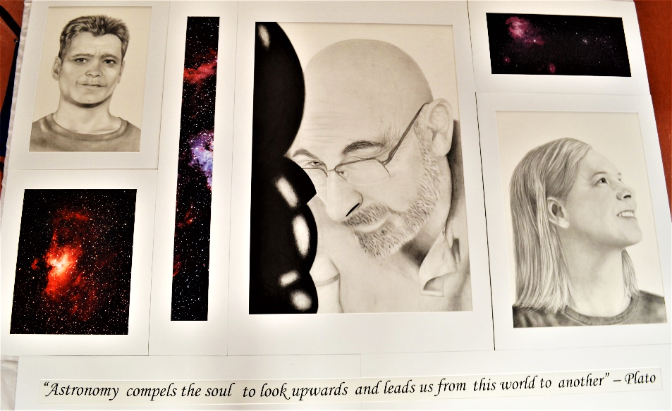
Kristie Caplikas , ‘The Crowd and the Cosmos’ (right) Graphite Pencil Drawings + Astronomy Photographs – 6 pieces
Artist Statement: Have you looked through a telescope and wondered just how much is out there? This perennial curiosity of the human mind drives us to study the closest of stars to the furthest, most remote corners of the universe. When we study the sky, we are looking into our own origins, because every single atom in our bodies was made inside the core a star. We are literally descended from the stars – they are our parents and our creators; we are truly the children of the stars. Contrasting the bright vivid colours my own images of exquisite southern sky nebulae with the black and white graphite portraits of Australian astronomers, my work reflects our attempts to reconnect with ourselves by means of exploration of our origins in the stars. We are a way for the universe to understand itself so when encountered with the millions of twinkling stars that litter the night sky, is there any choice but to explore?

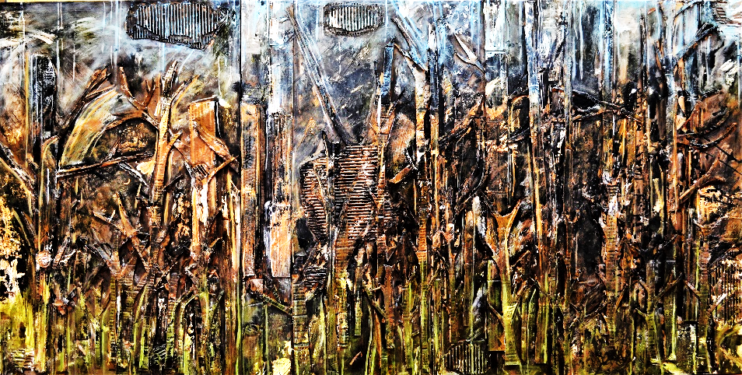
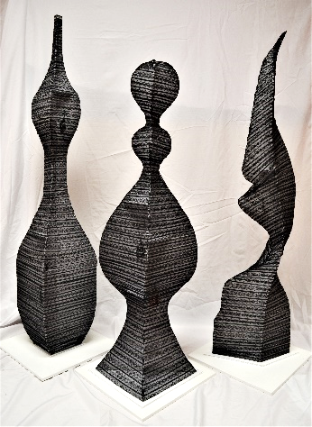
More HSC works!!

Broadie Mooney (left) ‘Regeneration’, Abstract Painting Acrylic on Board

Haydar Fanoosh (right) ‘Far from the Tree’ Sculptural Forms

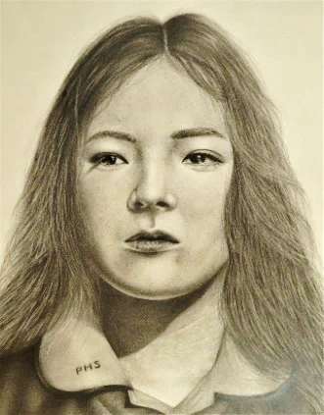
Competition Winner!!
Congratulations to our photography student, Robert Lin -Year 9 (below), for taking out 1st place in the Capture Fairfield Photography Competition with his cleverly composed image. Well done, Robert!

Select Year 11
Artworks 2020

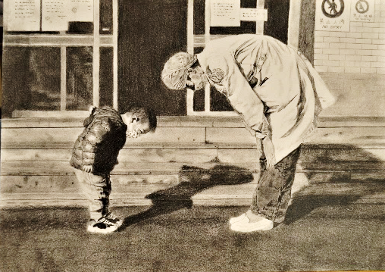

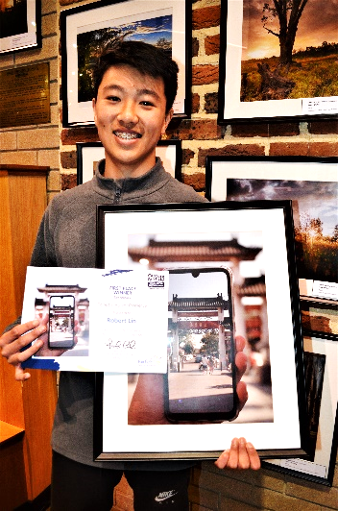
Keali Longdon
Narina Folino
Jiayu Xu
Nhi Lu

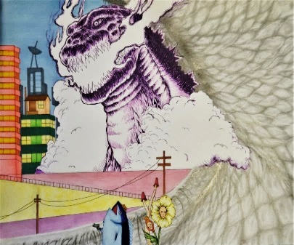
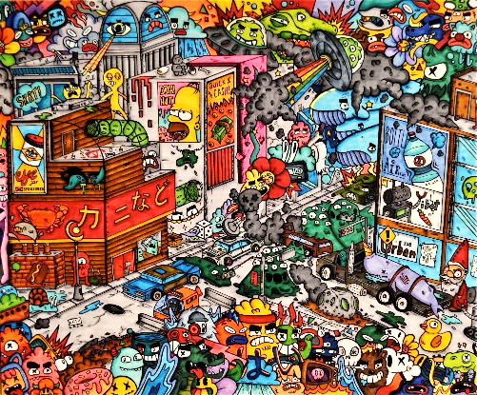
Jessica Luu
Nathan Nguyen

